Transportation Emergency Rescue Committee
:

The Atlantic Vehicle Rescue Challenge will be held between the dates of June 23-25 in North River PEI, Canada. This challenge is a TERC Canada sanctioned event open to all teams. Teams must be a current member of TERC Canadas. Visit our website www.terccanada.ca to learn more about the TERC organization and its benefits.

Each team will participate in three challenge pits, Limited, Unlimited & Rapid
Pits. The defining factor between the pits is the availability of rescue tools. The Limited Pit presents only hand and pneumatic tools, and the Unlimited pit, makes available all rescue tools, including heavy hydraulic rescue equipment. The teams have 20 minutes to safely extricate an entrapped patient (mannequin) from a simulated vehicle collision. The Rapid Pit is open to all tools but the teams will have only 10 minutes to safely extricate the patient from the scenario. The point scoring is primarily based on the command structure, hazard and scene control, patient and rescuer safety and the techniques used to disentangle the patient.

2023 Atlantic Vehicle Rescue Challenge

Hosted by the North River Fire Department

Limited to 10 Teams

Located at
644 Capital Drive, Cornwall PEI, C0A 1H8

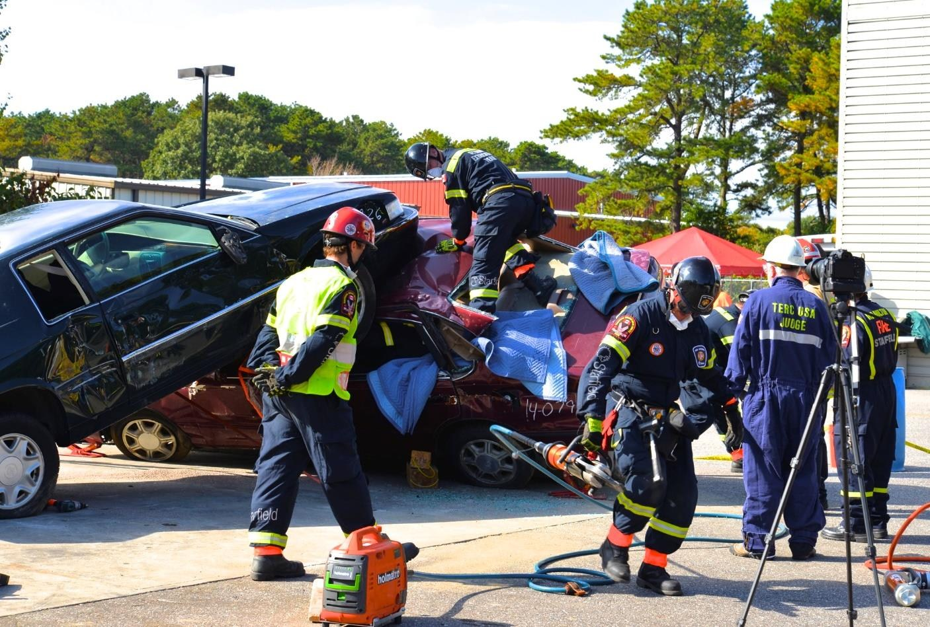

Team Registration

TERC Reg #:_________________ *Not a member of TERC please leave blank*

Team/Department Name:
_____________________________________________________________

Address: ___________________________________________________________

City: __________________________________

Province/State:________________________Postal Code/Zip:_______________

Country: _____________

Contact Name: ________________________________________________

Phone#:________________________

E-Mail:_____________________________________________________________

Please Indicate your Hydraulic Tool Manufacturer Preference: (TNT/Hurst etc.)
______________________________________________

Team Composition: (6 members) Shirt Size: S, M, L, XL, XXL

I.C.: _________________________ _______

Medic: _________________________ _______

Crew (1): _________________________ _______

Crew (2): _________________________ _______

Crew (3): _________________________ _______

Crew (4): _________________________ _______

Alternate: _________________________ _______

All Team Registrations must be accompanied with:

Team Waiver
Team Bio & Picture (Send as soon as possible to be included in program book)
Any Special needs team or team members require (example: scheduling) Entry Fee: $600.00
➢ All Forms and Payment must be received by May 20, 2023

Please Make checks payable to: “Terc Canada”

Mail to:
Eugene justason,
Po Box 364,
Musquodoboit Harbour, NS, B0J 2L0
E-Transfer to ebjustason@eastlink.ca security answer TERCAtlantic
For more information please contact Eugene Justason (902) 222 – 1081 or email at: justase@halifax.ca
Accommodations:

Hampton Inn and Suites

$ 179. 00Per Night
300 capital Drive, Charlottetown PE, C1E 3N1
Phone: (902) 3683142

Rate of $179.00 (standard) which will be available to book until 1700 may 23, 2023 or until the block is full

To make reservations please call number above

Tentative Schedule
Friday June 23,2023
Team Arrival and transport from Hotel
6:00pm – opening Ceremonies
8:00pm – Teams Captains Meeting

Saturday June 24, 2023
8:00am – 4:00pm - Competition Pits (Unlimited/Limited)

Sunday June 25, 2023
8:00am – 1200pm - Competition Day (Rapid Pits)
Closing ceremony

WAIVER AND RELEASE OF LIABILITY

Participating Department: ___________________________________________

I, the undersigned, who is about to participate in this event, hereby release, discharge, relinquish, give up, forego, waive and otherwise completely exonerate the municipality, of any liability, responsibility, culpability or other basis upon which they may otherwise be liable for any injury, illness, disability, incapacitation or other physical ailment which might arise in connection with this competition and any related activities.

I recognize and expressly accept the risks and responsibilities inherent in this activity and willingly accept such risks in consideration of my participation and recreational opportunities afforded me in connection with my attendance at this event.

This is intended to be a complete and full release, waiver and relinquishment, giving up, forgoing and discharging any and all claims or damages of any kind, character or description against the North River Fire Department and any of its agents, employees or others, acting on its behalf, as might arise during my attendance at the aforementioned event. I hereby agree to assume all risk for injury and damage to myself caused by any defect on the area being used for the event, and further specifically assume the risk of injury resulting from any personal equipment, which I use or neglect to use during my participation in the Competition.

This document is signed by me voluntarily, and I will hold the North River Fire Department and any of its agents or members free and clear from all responsibility by any reason of my being upon the property participating, practicing, or otherwise being involved in the competition and will hold each of the parties mentioned above harmless from any court costs, attorney’s fees or other expenses whatsoever caused by any suit or injury for damages brought by me or by one on my behalf.

I am over the age of eighteen (18) years, have read the above and voluntarily agree to the terms of this release and specific assumption of risk and so indicate by signing and dating this release in the places indicated below.

It is understood and agreed that this agreement is to be binding upon myself, my heirs, executors, administrators and assigns.

Name Signature Witness

____________________ _____________________ _____________________

____________________ _____________________ _____________________

____________________ _____________________ _____________________

____________________ _____________________ _____________________

____________________ _____________________ _____________________

____________________ _____________________ _____________________

Chief/Designate Name: __________________________________

Signature: _______________________________

Date: ____________________

COMPETITION RULES & REGULATIONS

- No team shall participate in any exercise unless authorized by the Competition Coordinator or his / her designate.
- Substitutes may be granted by the Competition Coordinator or his / her designate in the event of a “no-show” by any team member previously registered to participate. Substitutes will be chosen at random from volunteer rescuers from other teams.
- The Host department reserves the right to use information or photographs that may be obtained from the competition for educational and training purposes. At no cost to the Host department.
- The Host department will not be responsible for the damage or loss of equipment as a result of participating at this event.
- All scoring information shall remain the property of the host department and shall remain confidential. Each team will receive a copy of their score sheet by mail after the competition and only the results forwarded to TERC USA.
- There will be a time limit of twenty (20) minutes for each of the two scenarios. Ten (10) minutes for the rapid pit.
- Safety is a priority: Approved personal protective equipment must be utilized at all times to ensure skin, eyes, head and feet are protected from injury.
- Alcoholic beverages will not be present or consumed on the competition site during the hours of competition. Evidence of alcohol consumption will result in the team being disqualified.
- There will be a Team Captain’s meeting at (Date & Time to be Announced) for the purpose of discussing safety, scoring, judging, inspection of home-made tools and drawing times for scenarios. Attendance by Team Captains is mandatory. Judges, the Interior Patient Manager, Safety Officers and other officials will be present.
- The challenge will begin at 8:00 a.m. when the first competing team will present themselves to the Tool Boss. They will then be sequestered at 8:15 a.m. while the scenario is being set up and the first evolution will begin at 8:45 a.m.
- Each team must be present sixty ( 60 ) minutes prior to their start time at the Tool Pit to allow time to choose tools. Teams will be sequestered thirty minutes prior to their scenario.

- Teams will consist of a minimum of five personnel to a maximum of six.
One Captain and four or five squad members will be allowed to compete. There will be no alternate member. The same I.C. and three of the rescuers from the first scenario team must participate as part of the second scenario team. You may substitute one or two rescuers for the second scenario.
- Teams being unable to draw enough personnel from their own station or department will be allowed to bring in a maximum of two from a neighboring department. Separate waivers will have to be signed by each department Chief.
- Hand tool kits and shoring will be supplied by the Host department or any tool supplier on site. Participating teams are not required to supply their own tools, but if any home-made or unapproved tools are used in the competition, they must be examined and approved by the Head Judge and Safety Officer prior to being placed in the tool staging area.
- Limited Pit Category: Hand tools, saws-alls, hand-operated hydraulic and pneumatic tools, light enough to be operated by one rescuer.
- Unlimited Pit Category: Any approved tool carried on a first run apparatus is permitted, however, a maximum of two (2) hoses will be allowed. Therefore, any combination of tools and pumps can be staged, but only two may be used at the same time.
- RAPID PIT CATEGORY: ALL Tools are allowed for team to work with, while safely removing the patient within 10 minutes.
- All verbal commands during the scenarios will be audible to spectators and officials. No personal radio sets are allowed during the evolution. The I.C.
may carry a dummy radio to simulate communication with incident dispatch.
- The decision of the judges in final.
- No electronic devices (pagers, cell phones, etc.) will be allowed in the sequester area.
COVERALLS: If a rescue team is accustomed to wearing coverall-type equipment in place of the regulation firefighting gear on normal rescues, and elects to use coveralls, the team must produce a letter of approval from their Fire Chief.

SAFETY GUIDELINES
Safety Officer:
- The Safety Officer will have the authority to stop any evolution, when, in his judgment, there exists a potential danger to spectators or team members.
- The responsibility of the Safety Officer is to prevent injury through unsafe acts or hazardous conditions, and in conjunction with the Head Judge, inspects all unapproved tools presented by teams for use in the competition.
- The Team Captain is responsible for presenting home-made or unapproved tools or apparatus to the Head Judge and the Safety Officer for inspection prior to including that tool in the tool staging area.

PERSONAL PROTECTIVE EQUIPMENT
- The minimum requirement for the participants working in the pit area will be as follows: Approved head protection, eye protection, hand protection and safety footwear. Exposed skin from neck to toes to be covered at all times.
- The minimum requirements for the judges and safety officer, camera crews and equipment suppliers in the pit area will be as follows: Approved head protection, safety glasses and safety foot wear. Pit crews must wear hand protection while working in the pits or compound.
- No Smoking in the pit area or vehicle compound area.
- Pit and vehicle compound areas are out of bounds to spectators.
- “FREEZE” command by a judge or safety officer will identify an unsafe condition. The hand will be raised by the official giving the FREEZE command and the evolution and the time will be stopped immediately. The condition will be identified, the lead judge will verify that the I.C. understands the problem, and the evolution will be started again. A “FREEZE” command by an extrication team member does not stop the clock.
- All tools will be maintained in a safe operating condition. Defective tools will be removed from service immediately.
- Compensation coverage is the responsibility of the home Fire Department or Rescue Company.
- All personal injuries will be treated and reported to the committee, injuries must be reported immediately, not at the end of the scenarios or the end of the day. Injury reports will be sent to the Fire Chief of the injured person’s Fire Department.
- Failure to observe the Safety guidelines after a preliminary warning will result in the team’s disqualification

- All fuel tanks will be removed from the vehicles and all fluids will be drained before a vehicle enters the compound.

